Lab 4C Internet of Things
This laboratory assignment accompanies the book, Embedded Systems: Real-Time Interfacing to ARM Cortex M Microcontrollers, ISBN-13: 978-1463590154, by Jonathan W. Valvano, copyright © 2015.

Goals
- Implement a system that connects to the internet via an IEEE 802.11 – Wifi module, CC3100
- Use DNS to convert name to IP address
- Configure a smart object that can retrieve data from a weather server using TCP
- Design a smart object that can store data onto an internet server using TCP

Review
- Valvano Section 11.4 on internet of things
- cc3100_getting_started_guide_swru375.pdf (in \ValvanoWareTM4C123\CC3100_docs)
- cc3100_boost_user_guide_swru371.pdf (in \ValvanoWareTM4C123\CC3100_docs\hardware)
- cc3100_boost_sch_rev3p3-a.pdf (in \ValvanoWareTM4C123\CC3100_docs\hardware)

Starter Project
- CC3100GetWeather_4C123 in ValvanowareTM4C123 (main.c 7/2015 date or later)
- ESP8266_4C123 in ValvanowareTM4C123 (9/19/2015 date or later)

Background
Wifi is the name given to devices that communicate wirelessly employing the IEEE 802.11 standard. They typically operate in the 2.4 GHz Industrial-Scientific-Medical (ISM) unlicensed band that is shared with ZigBee (IEEE 802.15.4) and Bluetooth (IEEE 802.15.1) communications. The IEEE 802.11 standard describes how information is represented via radio frequency signals, i.e., the physical or PHY layer, and how communications are formatted and controlled, i.e., the media access control or MAC layer. Communication requirements beyond the PHY and MAC, e.g., flow control, error recovery, and routing, are handled at higher levels of the internet stack.
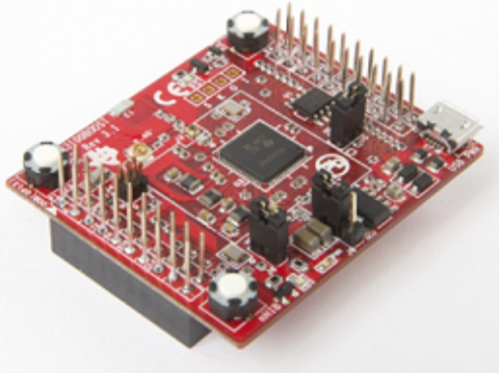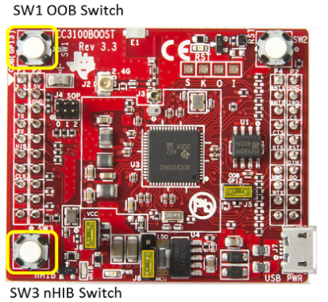
Figure 4.1. The TI CC3100 Wifi booster pack (CC3100BOOST).

Required Hardware www.ti.com
CC3100BOOST Wifi Booster $19.99
EK-TM4C123GXL Tiva LaunchPad $12.99
The emulation module (CC31XXEMUBOOST) is needed only if you wish to upgrade or reprogram the CC3100BOOST. The emulation module could also be used for situations where you wish to begin wireless programming before you have selected which microcontroller to use.

Specifications
This lab will create a “smart object” or “internet of things”. Your system includes
- a PC, running PuTTY, connected to the TM4C123 through UART0 (optional for debugging)
- a TM4C123 LaunchPad running your software
- a CC3100BOOST Wifi booster pack connected to the internet
- a ST7735R or Nokia 5110 LCD showing weather data
- a sensor generating a voltage connected to an ADC (e.g., a 10k slide pot, or internal temperature sensor)
- a wireless access point, configured with or without security.

You are free to define the “look and feel” of your system however you wish as long as you pull data from the weather server and push data to the EE445L server using TDP packets over the wifi link. Feel free to write your code using the style found in the TivaWare driver or in the style found in the book. The starter project was derived from TI’s TivaWare, so much of CC3100GetWeather_4C123 is written in TivaWare style. You may perform this lab with Keil 4.7 or CCS.

Interfaces
The TM4C123 bus clock will be 50 MHz. The PC is connected to the LaunchPad via UART0, which is embedded in the standard USB debugging cable. This link is used for debugging. The starter code uses 115200 bits/sec, 1 stop, no parity, and no flow control. Use the Windows device manager to determine the COM port used to communication with your LaunchPad. The CC3100/LaunchPad interface is shown in Figure 4.2 and Table 4.1. This interface uses GPIO, SSI, and UART ports on the LaunchPad.
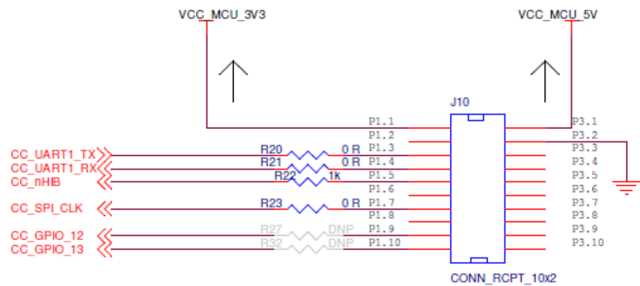
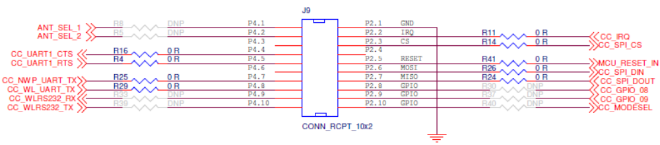
Figure 4.2. The CC3100-LaunchPad interface (DNP means do not populate).

Pin Signal Direction Pin Signal Direction
P1.1 3.3 VCC IN P2.1 Gnd GND IN
P1.2 PB5 SPI2_FSS IN P2.2 PB2 IRQ OUT (GPIO interrupt)
P1.3 PB0 UART1_TX OUT P2.3 PE0 SPI_CS IN
P1.4 PB1 UART1_RX IN P2.4 PF0 UNUSED NA
P1.5 PE4 nHIB IN P2.5 Reset nRESET IN
P1.6 PE5 UNUSED NA P2.6 PB7 SPI2_MOSI IN
P1.7 PB4 SPI2_CLK IN P2.7 PB6 SPI2_MISO OUT
P1.8 PA5 UNUSED NA P2.8 PA4 UNUSED NA
P1.9 PA6 UNUSED NA P2.9 PA3 UNUSED NA
P1.10 PA7 UNUSED NA P2.10 PA2 UNUSED NA

Pin Signal Direction Pin Signal Direction
P3.1 +5 +5 V IN P4.1 PF2 UNUSED OUT
P3.2 Gnd GND IN P4.2 PF3 UNUSED OUT
P3.3 PD0 UNUSED NA P4.3 PB3 UNUSED NA
P3.4 PD1 UNUSED NA P4.4 PC4 UART1_CTS IN
P3.5 PD2 UNUSED NA P4.5 PC5 UART1_RTS OUT
P3.6 PD3 UNUSED NA P4.6 PC6 UNUSED NA
P3.7 PE1 UNUSED NA P4.7 PC7 NWP_LOG_TX OUT
P3.8 PE2 UNUSED NA P4.8 PD6 WLAN_LOG_TX OUT
P3.9 PE3 UNUSED NA P4.9 PD7 UNUSED IN (see R74)
P3.10 PF1 UNUSED NA P4.10 PF4 UNUSED OUT(see R75)
Table 4.1. CC3100 connections to the TM4C123 LaunchPad (PB5 is enabled as FSS but not connected).

Preparation
Part a) Watch the 10 short videos Yerraballi and Valvano created for the MOOC. The YouTube channel is at
https://www.youtube.com/playlist?list=PLyg2vmIzGxXGy6TnmO1tyR33HW6n9IvPr

Part b) Find the CC3100GetWeather_4C123 project in ValvanowareTM4C123 and make sure the main.c file has a date of July 2015 (or later). Make a copy of this project that will become your Lab 4C solution. You should be able to compile this project. http://edx-org-utaustinx.s3.amazonaws.com/UT601x/ValvanoWareTM4C123.zip

Part c) On both CC3100GetWeather_4C123 and your Lab4C project, modify lines 97 98 99 so that the smart object can connect to your access point. This is how I connect to my cell phone.
#define SSID_NAME "ValvanoJonathaniPhone"
#define SEC_TYPE SL_SEC_TYPE_WPA
#define PASSKEY "y2uvdjfi5puyd"
There are nine choices for the SEC_TYPE (see lines 141-149 of wlan.h file). The above code selects WPA encryption, but I have also used SL_SEC_TYPE_OPEN, which means no encryption.

Part d) Use openweathermap.org and search for the current temperature in Austin Texas. Figure 4.3 shows the contents of the TCP payload, Recvbuff, which is returned by openweathermap.org when a smart object queries it for Austin’s weather. Observe the Austin temperature data highlighted in yellow. Write a C function that extracts the Austin temperature from this buffer. Create a fixed-length string like "Temp = 8.568 C"

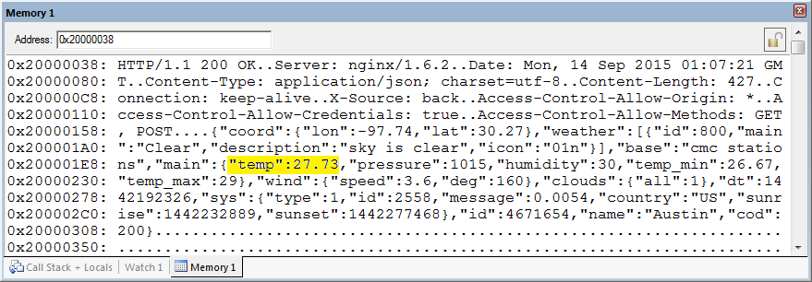
Figure 4.3. Example Recvbuff response from the openweathermap.org server.

Part e) If you have an ST7735R add your ST7735.c and ST7735.h driver files to the project, otherwise you can interface a Nokia 5110. After receiving the weather information, run the function in Part d) to parse the TCP packet in Recvbuff, and display the Austin temperature on the LCD. Each time you press and release the button the temperature data should update.

Part f) Write software to sample the ADC once using 64-point hardware averaging and calculate a physical parameter with units. Examples include but are not limited to a voltmeter, an ammeter, a distance measurement (slide pot like EE319K), or an internal temperature measurement (see section 13.3.6 and register ADCSSCTL3 in the data sheet). Create an ASCII string similar to
Voltage~1.23V
Current~123uA
Distance~1.23cm
Int_Temp~41C
Avoiding characters = & % ? \n \r and spaces will simplify parsing in the server. Add code to the main loop, so the ADC is sampled, the parameter is calculated, the string is created, and the results are displayed on the LCD each time the switch is pressed.

Procedure
Part a) You will need to debug code with a wifi access point for which you know the SSID, type of encryption, and password. First verify the hardware configuration is operational by running the original CC3100GetWeather_4C123 project with lines 97-99 modified to connect to your access point. You can observe the returned weather in the debugger or using PuTTY.

Part b) Debug your code at parses the Recvbuff and displays the Austin temperature.

Part c) Debug your code at samples the ADC, calculates a parameter, creates a string, and outputs to the LCD.
Part d) Go to embedded-systems-server.appspot.com and observe the look and feel for the EE445L data logging server. There are fields for where the data was collected, who collected the data, and the data itself.

Part e) Write code that gets called once in your main loop after the ADC is sampled and converted to a string. Log this information onto the server using these steps in a similar manner to getting weather data:
- Use sl_NetAppDnsGetHostByName to find the IP address of embedded-systems-server.appspot.com
- Use sl_Socket to create a socket
- Use sl_Connect to open the socket
- Use sl_Send to send a TCP packet to the server
- Use sl_Recv to receive a response from the server
- Use sl_Close to close the socket
The format of the TCP payload you will send is

GET /query?city=<city>&id=<name>&greet=<data>&edxcode=8086 HTTP/1.1\r\nUser-Agent: Keil\r\nHost: embedded-systems-server.appspot.com\r\n\r\n

where <city> specifies where the data was collected, <name> includes you and your partner, and <data> is the measurement. If you wish to include spaces use %20 and use %3D if you want an equals sign. For example
GET /query?city=Austin%20Texas&id=Jonathan%20Valvano&greet=Int%20Temp%3D21C&edxcode=8086 HTTP/1.1\r\nUser-Agent: Keil\r\nHost: embedded-systems-server.appspot.com\r\n\r\n

Part f) Instrument the system so you can measure the time it takes to collect weather data from the internet and how long it takes to store data on the EE445L server. Run it 10 times and calculate the minimum, maximum, and average times and record the number of lost packets (number of failures).

Deliverables (exact components of the lab report)
- Objectives (1/2 page maximum)
- Hardware Design (only if needed for the sensor)
- Software Design (a hardcopy software printout is due at the time of demonstration)
- Measurement Data
Percentage of lost packets. Basically how reliable is the system (assuming you have a connection to the AP)
Minimum, maximum, and average times from 10 transmissions to openweathermap.org
Minimum, maximum, and average times from 10 transmissions to EE445L server
- Analysis and Discussion (1 page maximum)
1) In the client server paradigm, explain the sequence of internet communications sent from client to server and from server to client as the client saves data on the server. Assume the client already is connected to the wifi AP and the client knows the IP address of the server.
2) What is the purpose of the DNS?
3) What is the difference between UDP and TCP communication? More specifically when should we use UDP and when should we use TCP?

Checkout
Demonstrate that your system can display data and log measurements on the EE445L server. (It is easy to spoof the server so you will have to show your system running to the TA)
Upload your software as instructed by your TA.

Extra credit
Perform at most one of these for an extra 10%. Extra credit is in addition to the regular lab.
0) Create your own data logging server which has another field, and log data onto it.

1) Looking over the list of starter projects listed in book Section 11.4.8, find something interesting and propose it to your TA. Please get approval first, before spending a lot of time.

2) Combine Labs 3 and 4 and use the GMT in the weather packet to synchronize their alarm clock. In order to make it all fit within 32k limit you can use CCS or simplify the clock.

